**OOPs Lab file**

Name : Mohammad Wasi

SAP ID : 500110709

Submitted to : Amit Verma Sir

EXPT 2.3

1)Write a program to find the largest of 3 numbers.

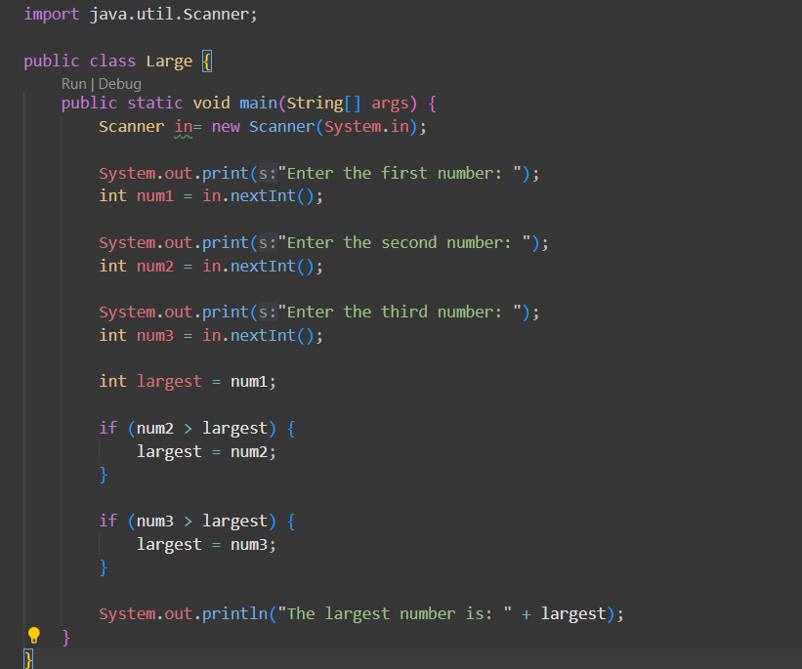

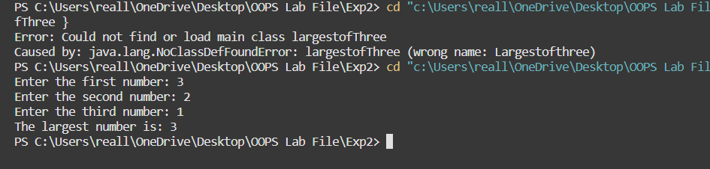

2)Write a program to add two amber using command line arguments.

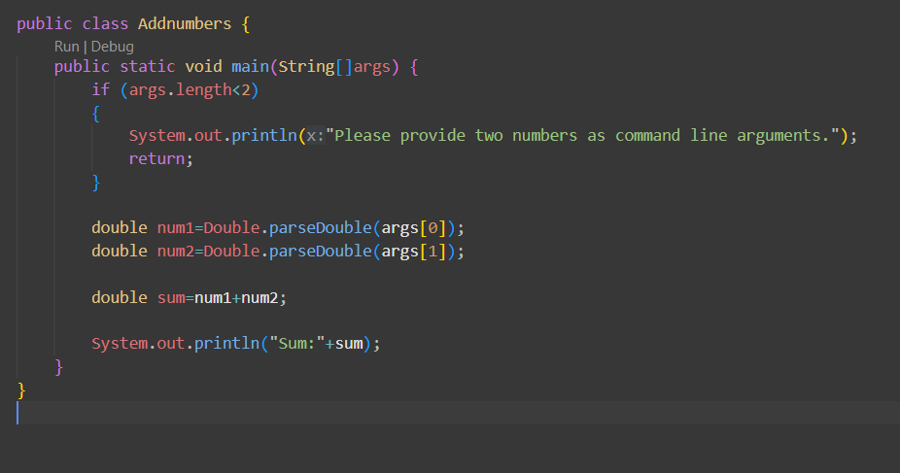

3) Write a program to print Fibonacci series using loop.

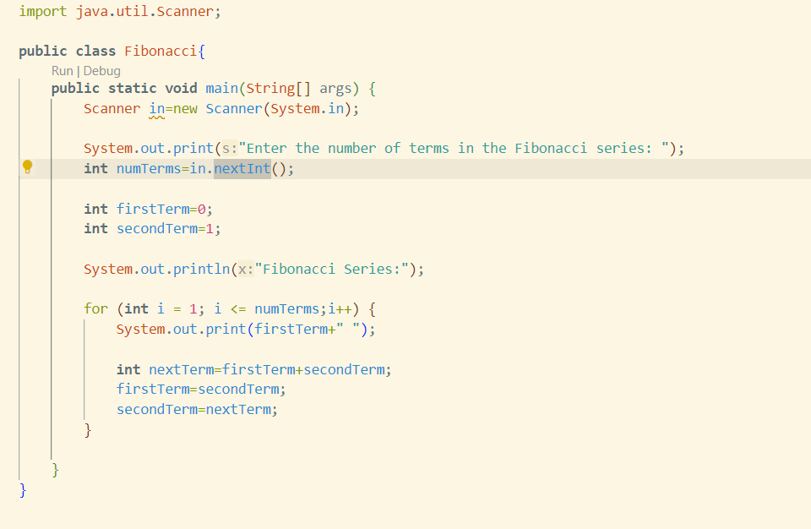

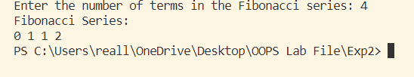

4) Write a programming classes and object in java.

5) Write a program to accept 10 student's marks in array, arrange it into ascending order, convert into the following grades and print marks and grades in the tabular form.

Between 40 and 50; PASS

Between 31 and 75; MERIT

and above: DISTINCTION

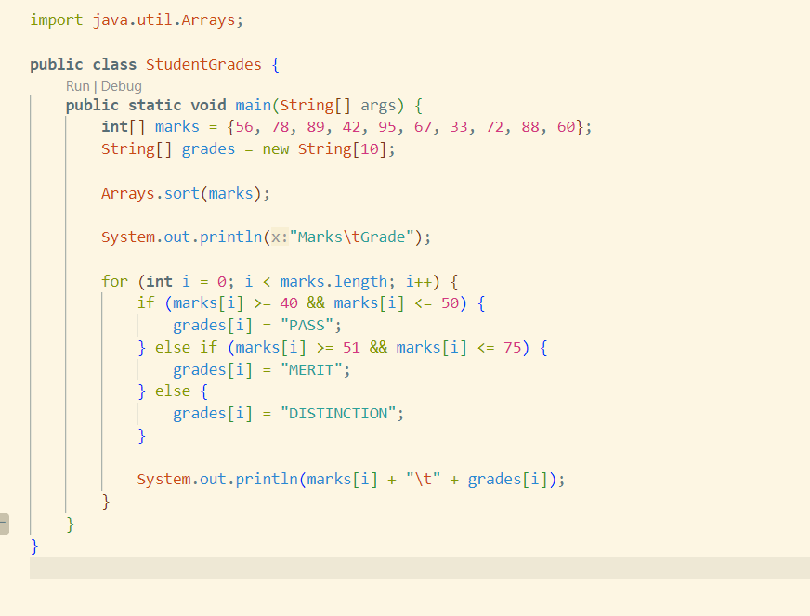

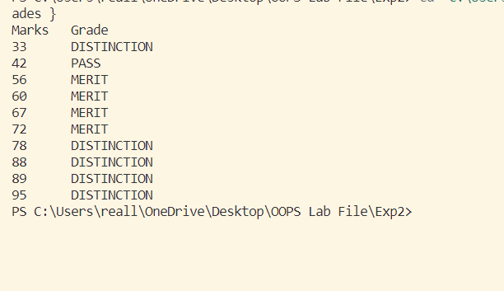

6)Write a Java Program to accept 10 numbers in an array and compute the square of each number.

Print the sum of these numbers.

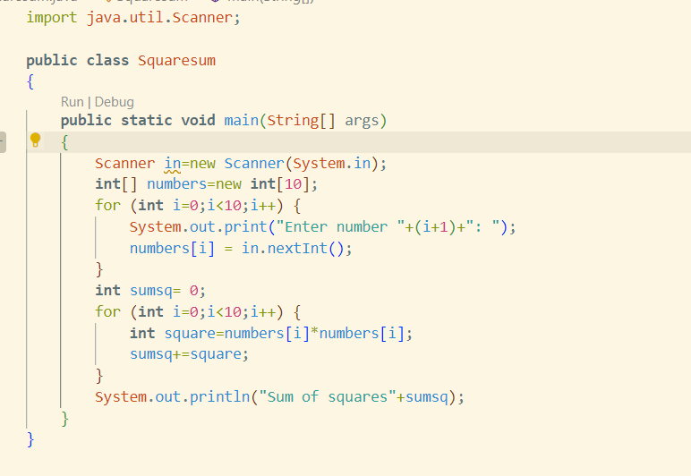

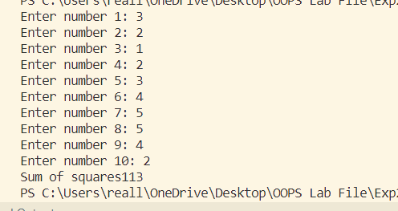

7)Write a program to find the sum of all integers greater than 40 and less than 250 that are divisible by 5.

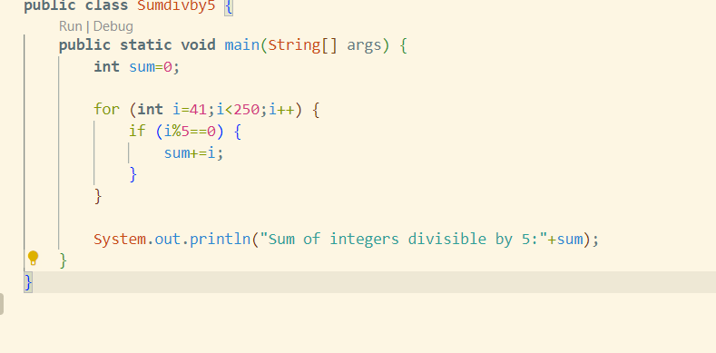

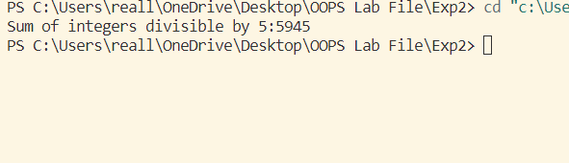

Lab 2

1. WAP to print your name.

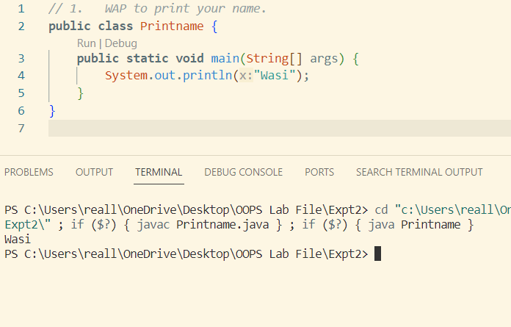

1. WAP to sum two integer numbers, declare non static integers in main function.

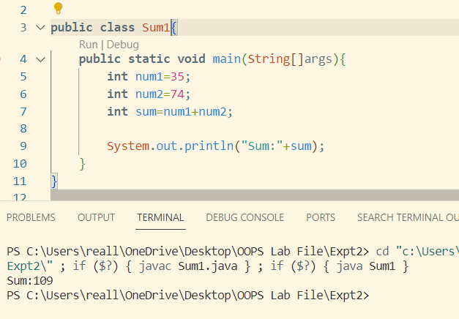

1. WAP to sum two integer numbers, declare non static integers in class other than the main class.

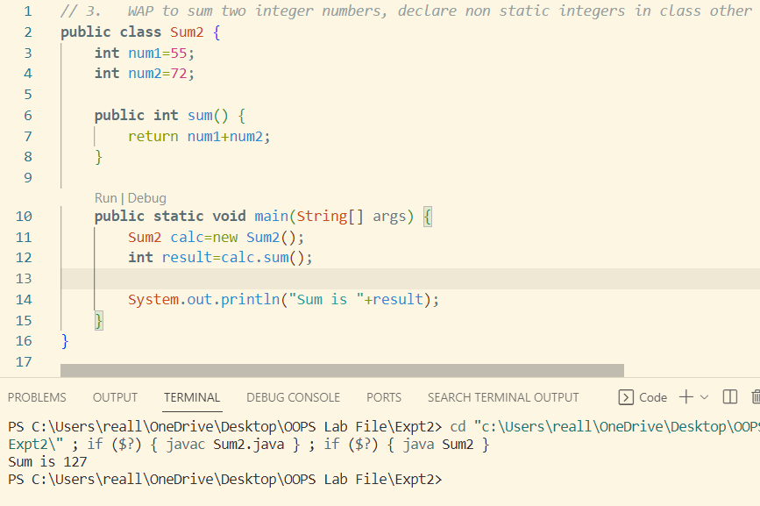

1. WAP to sum two integer numbers, declare static integers in class other than the main class.

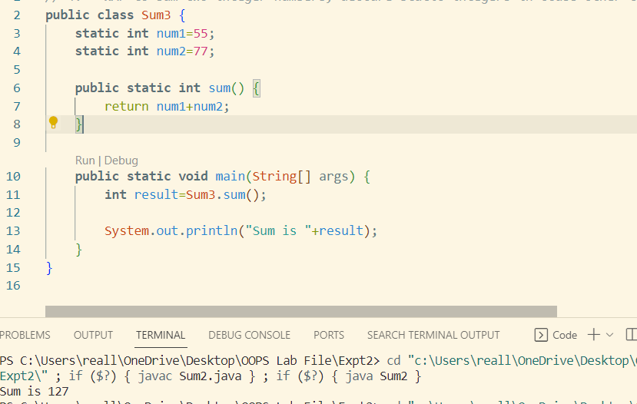

1. WAP to sum two integer numbers, declare non static integers in the member input function of the class other than the main class and display result using function display.

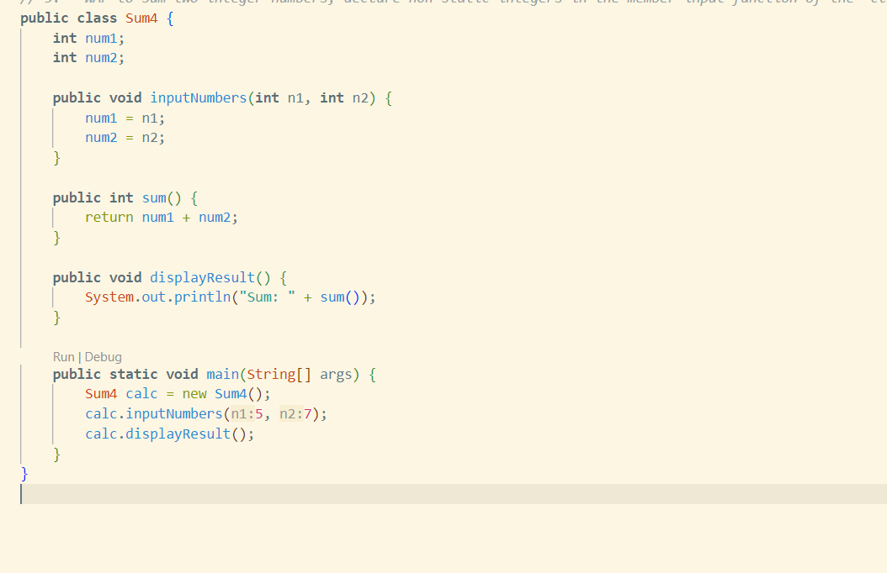

1. WAP to calculate the area of circle (take value of pi as final).

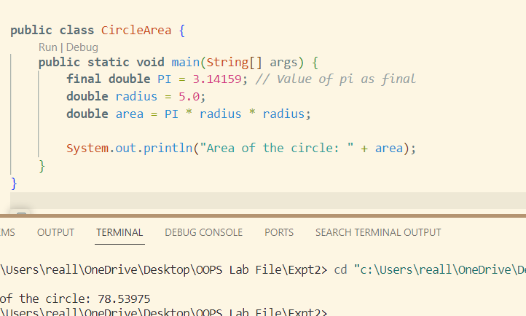

LAB 1

Topic – primitive data types, wrapper class, loops, arrays.

Date – 21-8-23 (OOPs Java) Room 10005 Time – 1 to 3PM

1. WAP to calculate factorial of 5 using int variable and object of Integer wrapper class.

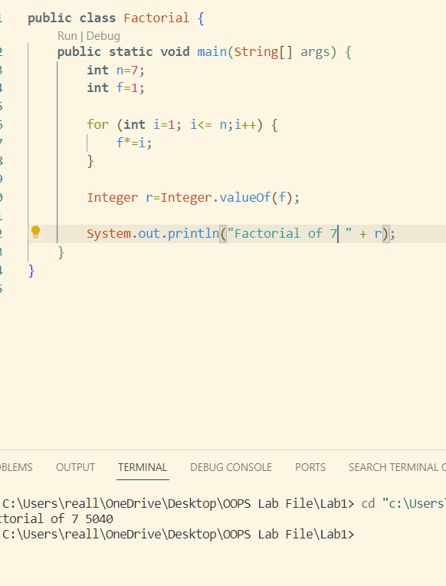

1. WAP to calculate the sum of first 50 natural numbers.

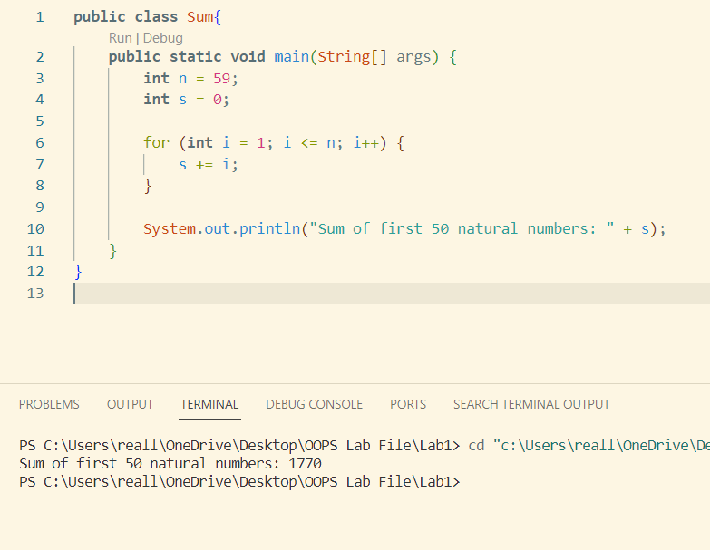

1. WAP to find the average of an array with 5 elements (10 to 50).

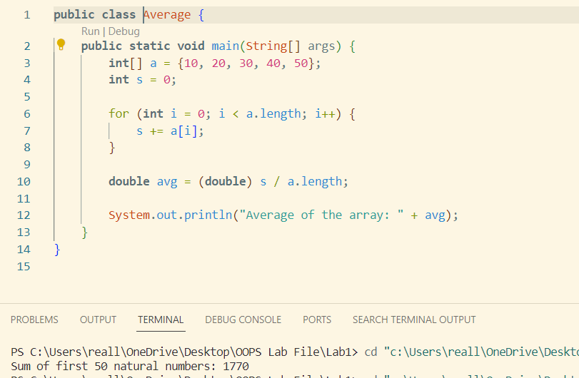

1. WAP to parse a double from a string using parseDouble().

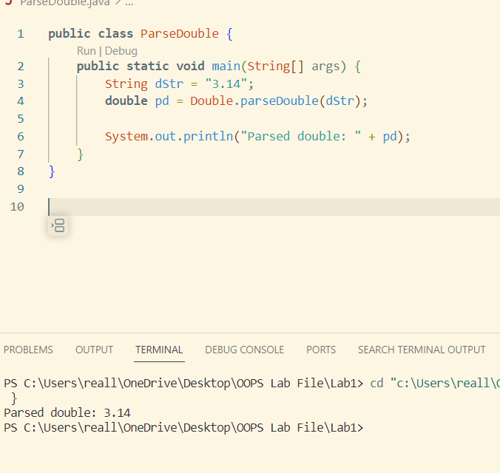

1. WAP to parse an integer from a string using parseInt().

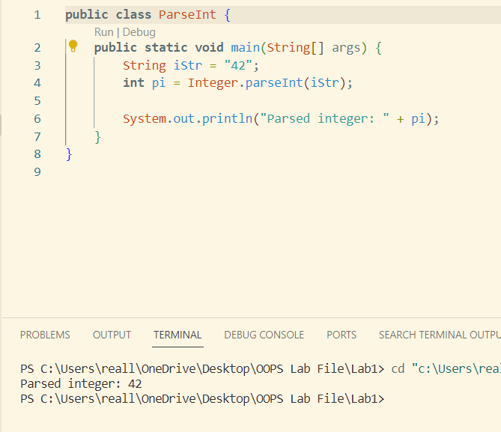

1. WAP to convert integer to string.

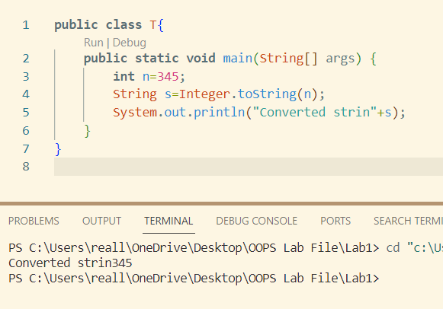

1. WAP to compare two objects of wrapper class Integer using equals.

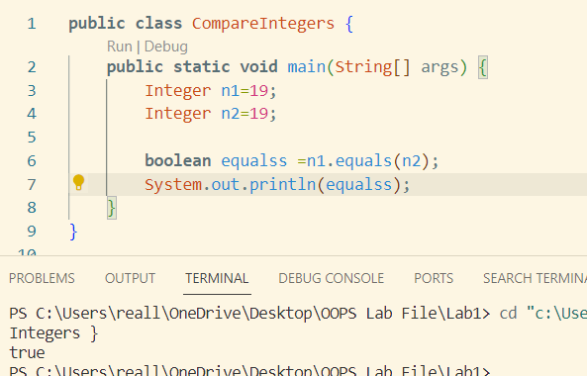

1. WAP to print the following pattern

*

* *

* * *

* *

*

*

* * *

* * * * *

1. WAP to create and initialize 2D array of 2x2 and find the sum of all elements of an array.

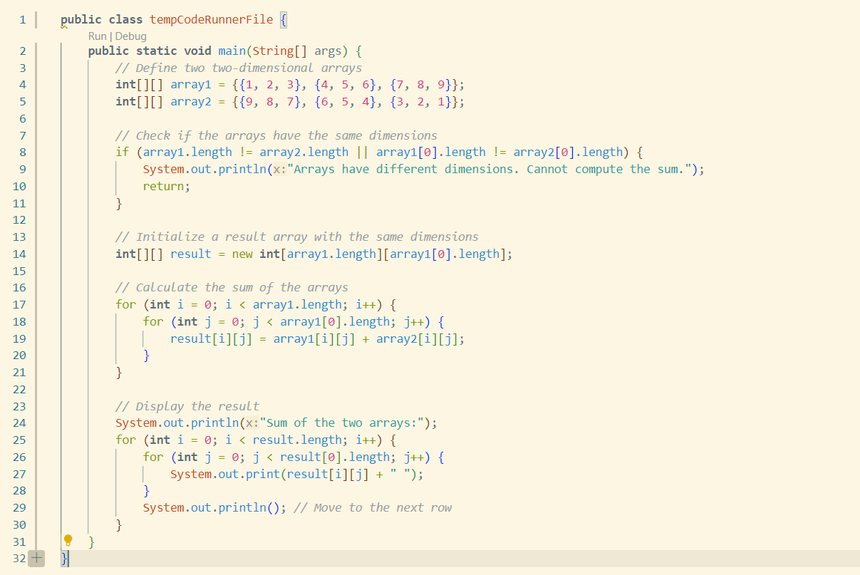

**Lab 130923**

* + - 1. Book

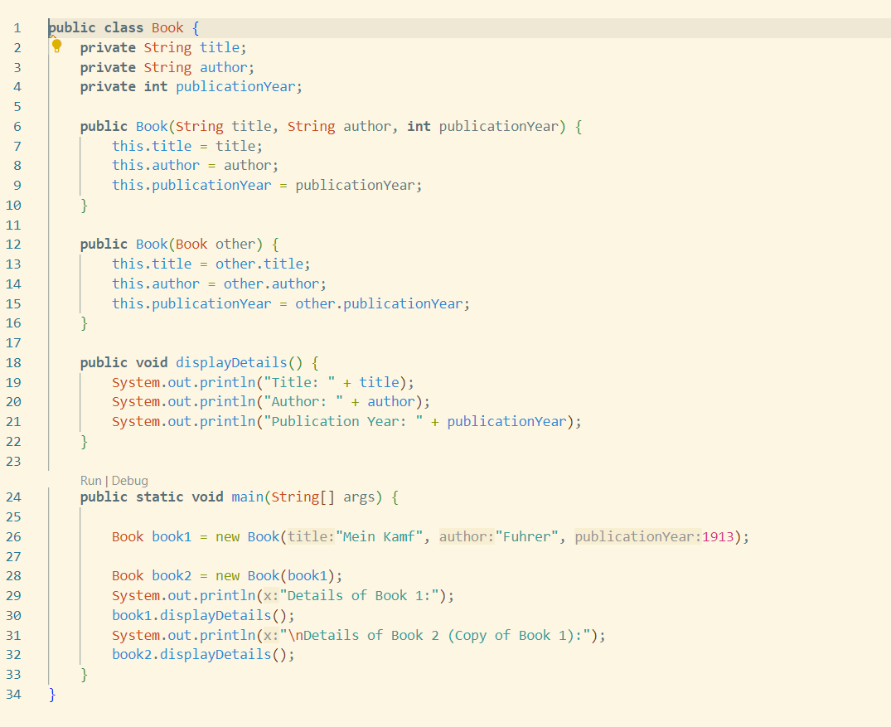

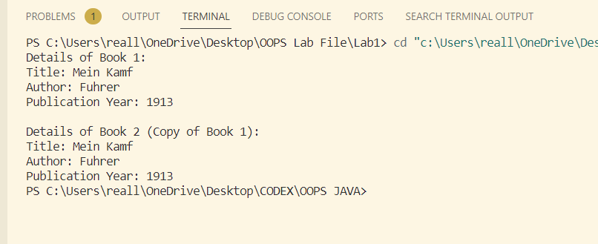

2. inheritance

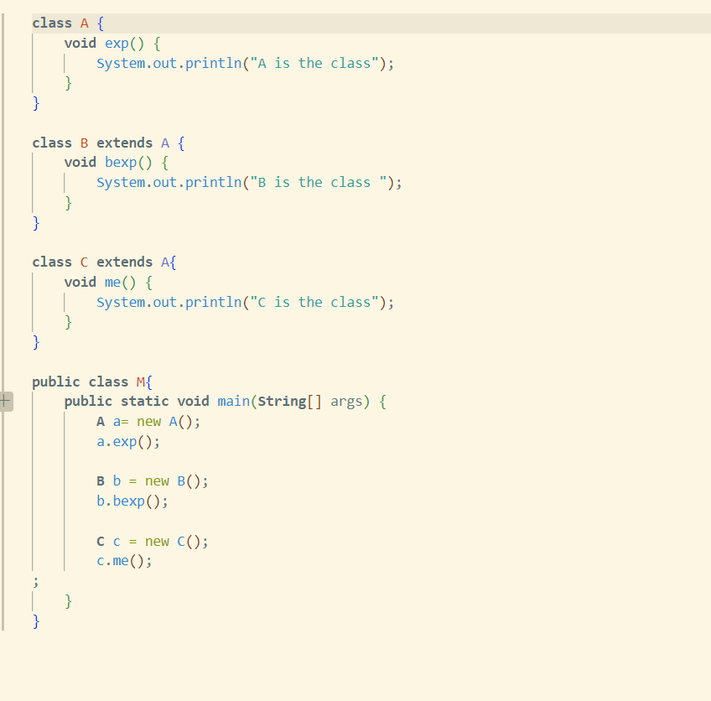

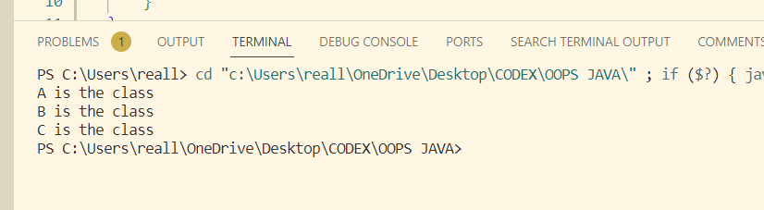

3 *// implement a class Rectangle that contains constructor to initialize values of length and breath using this keyword, and compute its area using the function CalculateAreafunction and return and display area  in java*

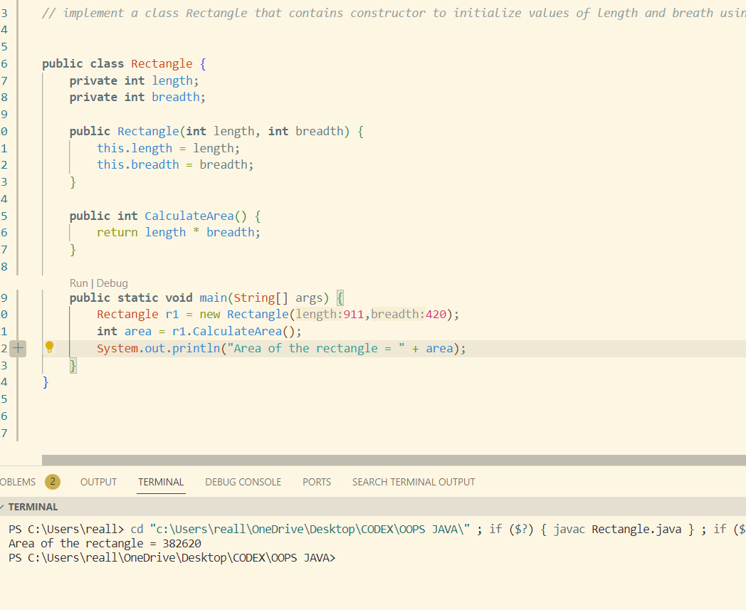

4 *// implement a program A parametrized constructor that initializes the student's name , roll number , course .A method called displayDetails that prints all the details i*

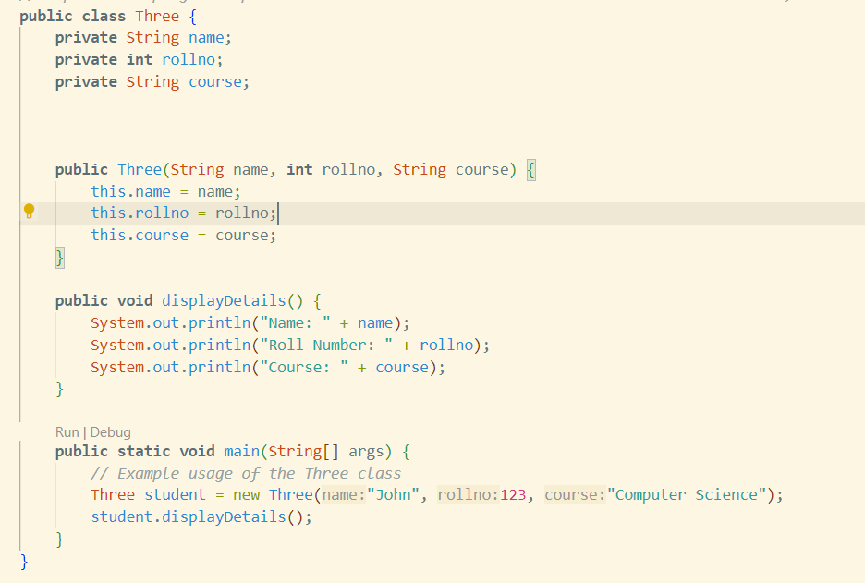

**Experiment Inheritance**

1. Implement a program to left-shift and right-shift a binary number by a specified number of positions.

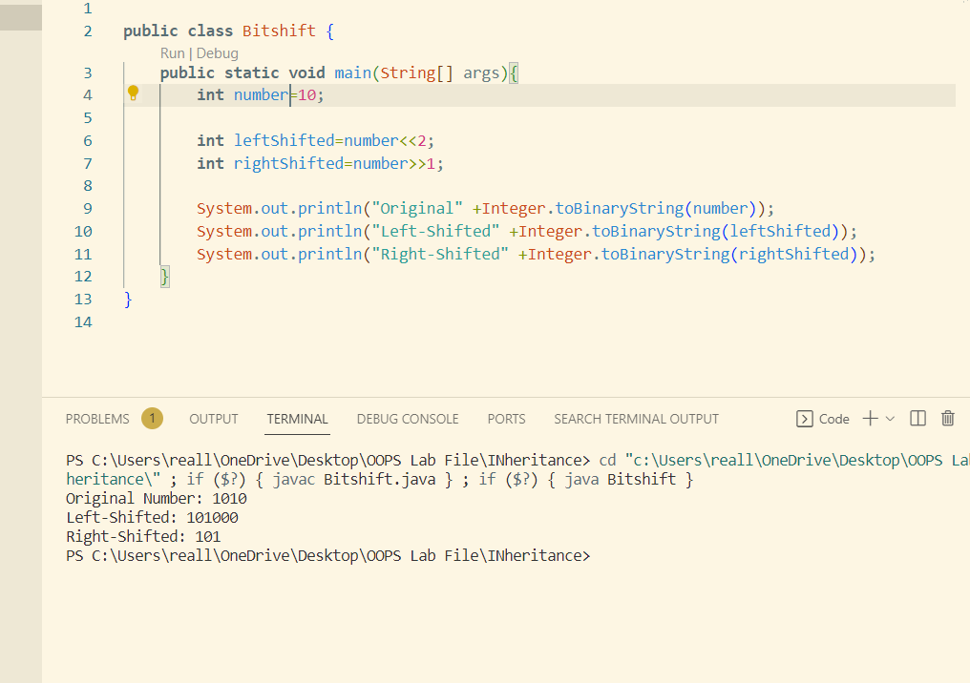

1. Write a program to simulate logical AND and OR operations on boolean.

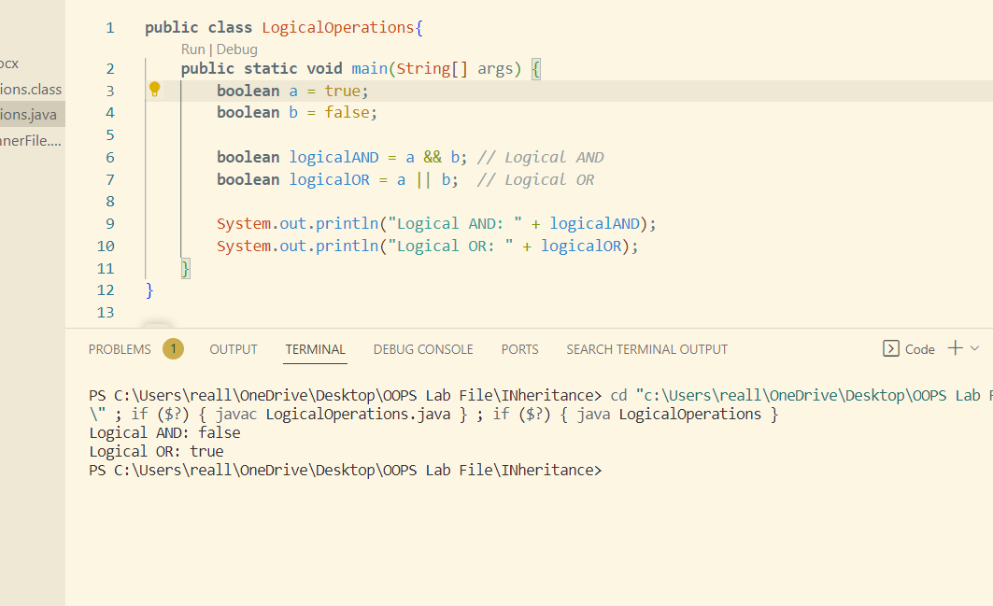

1. Write a program to find the maximum of two numbers using the ternary operator (a > b ? a : b).

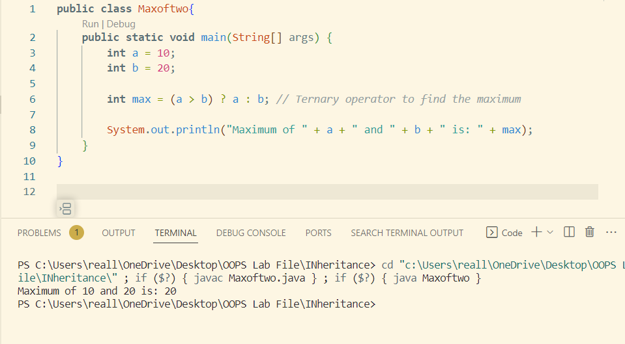

1. Write a program to simulate logical AND and OR operations on Boolean

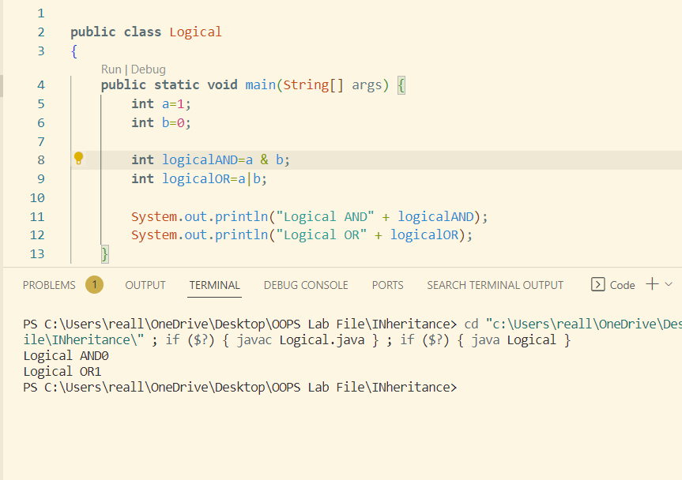

5,. Create a base class (superclass) and a derived class (subclass) with a few attributes and methods. Demonstrate inheritance by accessing superclass and subclass members.

class A {

private int numberA;

public A(int numberA) {

this.numberA = numberA;

}

public void displayInfoA() {

System.out.println("Number in A: " + numberA);

}

}

class B extends A {

private int numberB;

public B(int numberA, int numberB) {

super(numberA);

this.numberB = numberB;

}

public void displayInfoB() {

System.out.println("Number in B: " + numberB);

}

}

class C extends A {

private int numberC;

public C(int numberA, int numberC) {

super(numberA);

this.numberC = numberC;

}

public void displayInfoC() {

System.out.println("Number in C: " + numberC);

}

}

public class InheritanceDemo {

public static void main(String[] args) {

B myB = new B(10, 20);

C myC = new C(30, 40);

myB.displayInfoA();

myB.displayInfoB();

myC.displayInfoA();

myC.displayInfoC();

}

}